Linear Algebra

Laboratory Activity No. 8

**System of Linear Equations**

*Submitted by: Instructor:*

Parco, Jovian Asher G. Engr. Dylan Josh D. Lopez

December 22, 2020

# Objectives

This laboratory activity aims to implement the system of linear equations using Python programming, solving the system of linear equations using different linear algebra, and using a system of linear equations real-life practical problems.

# Methods

In this laboratory activity, the practices consist of recognizing the problem and their equivalent linear equations models using Numpy array() function, solving it using Numpy linag.inv() function, and the Numpy dot product() function.

# Results

The complete repository for the activity is available at Github (http://bit.ly/3haAgOx). The lab activity consists of only one part: the researcher must think of a problem with two unknowns and solve it using the system linear equations and inverse equations.



Figure Problem Created for the Activity

The researcher created a problem (Figure 1) where there are two unknowns: the price of the shark’s fin and Asian chicken where the two students buy a certain amount of the meal with the only total price is given while the price of the meal itself is unknown.

$$LET:C=ASIAN CHIKEN, S= SHARKS FIN$$

$$I=2C+2S=264$$

$$Chi=5C+1S=472$$

$$\left[\begin{matrix}2 & 2 \\ 5 & 1\end{matrix}\right]·\left[\begin{aligned}a \\ b\end{aligned}\right] =\left[\begin{aligned}264 \\ 472\end{aligned}\right]$$

The researcher analyzed the problem and created a model of it using a system of a linear equation, and converted it into matrix form.

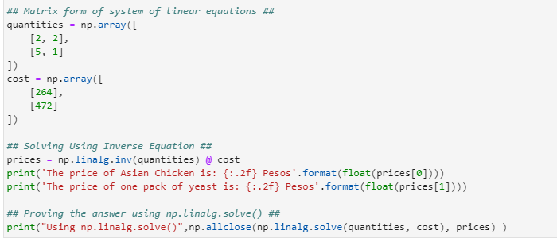

Figure Python Implementation of the Problem

The researcher implemented the given system of the linear equation and transformed it into a matrix form using the Numpy array() function with the quantities buy with respect to the meal and the total cost of the two students, using the inverse method where the researcher use the linalg.inv() function and the dot product of it to solve the two unknows, which is the price of the meal, and the second part of the code is the comparison between inverse method and linalg.solve function which the same but the way as the inverse but efficient the only downside is that the person using linalg.solve doesn’t know how it is solved.

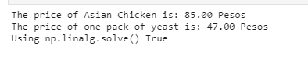

Figure Output of the Python Implementation

For the output of the code, the researcher figures out each meal’s price and proves that the Numpy.linalg.solve() function is similar to the inverse method.

# Conclusion

Scientist and engineers have always used the system of a linear equation to solve many practical problems because it can solve anything just with enough inputted data; this is especially useful for robotics, for example in a autonomous car that calculates how far is person with respect to the car or how likely it will hit something based on the cars postion and the object using 3d graphs and system of linear equations it can calculate the exact point in space the collision.**References**

[1] “Solving Systems of Equations Word Problems.” https://www.algebra-class.com/solving-systems-of-equations.html (accessed Dec. 18, 2020).

[2] “Paotsin delivery in Pasay City| Food Delivery Pasay City | foodpanda.” https://www.foodpanda.ph/chain/cc0ty/paotsin# (accessed Dec. 18, 2020).

[3] H. Cohn, R. Kleinberg, B. Szegedy, and C. Umans, “Group-theoretic algorithms for matrix multiplication,” *Proc. - Annu. IEEE Symp. Found. Comput. Sci. FOCS*, vol. 2005, pp. 379–388, Nov. 2005, doi: 10.1109/SFCS.2005.39.

[4] “Carl Meyer: Matrix Analysis - Download Chapters.” https://web.archive.org/web/20010301161440/http://matrixanalysis.com/DownloadChapters.html (accessed Dec. 22, 2020).

[5] “A first course in linear algebra; with optional introduction to groups, rings, and fields : Beauregard, Raymond A : Free Download, Borrow, and Streaming : Internet Archive.” https://archive.org/details/firstcourseinlin0000beau (accessed Dec. 22, 2020).